8.3 Bond energy
Name: ____________________ Class: ____________________ Due date:
1. Hydrogen burns exothermically in oxygen.
The equation for the reaction is:
2H₂ + O₂ → 2H₂O
The table shows the bond energies involved.
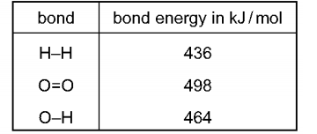
What is the energy given out during the reaction? （ ）
A −3226 kJ/mol B −884 kJ/mol C −486 kJ/mol D −442 kJ/mol

2. Hydrazine, N₂H₄, decomposes as shown.
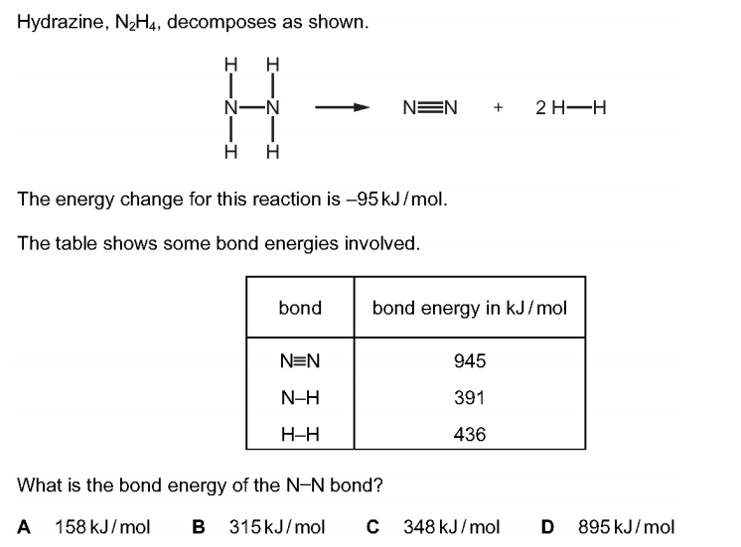
The energy change for this reaction is −95 kJ/mol.
The table shows some bond energies involved.
What is the bond energy of the N–N bond? （ ）
A 158 kJ/mol B 315 kJ/mol C 348 kJ/mol D 895 kJ/mol

3. The equation for the reaction between hydrogen and chlorine is shown.
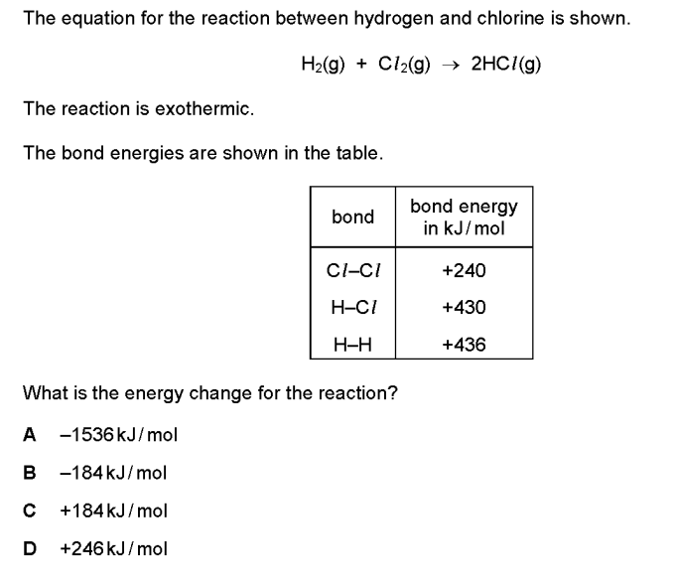
The reaction is exothermic.
The bond energies are shown in the table.
What is the energy change for the reaction? （ ）
A −1536 kJ/mol B −184 kJ/mol C +184 kJ/mol D +246 kJ/mol
4. The energy level diagram for the combustion of methane is shown.
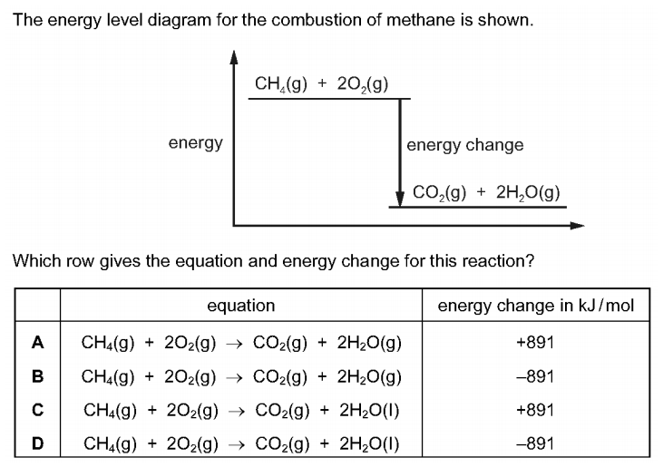
Which row gives the equation and energy change for this reaction? （ ）

5. Which statement describes an exothermic reaction? （ ）
A The energy absorbed for bond breaking is greater than the energy released by bond formation.
B The energy absorbed for bond breaking is less than the energy released by bond formation.
C The energy released by bond breaking is greater than the energy absorbed for bond formation.
D The energy released by bond breaking is less than the energy absorbed for bond formation.

6. The equation for the combustion of methane is shown.
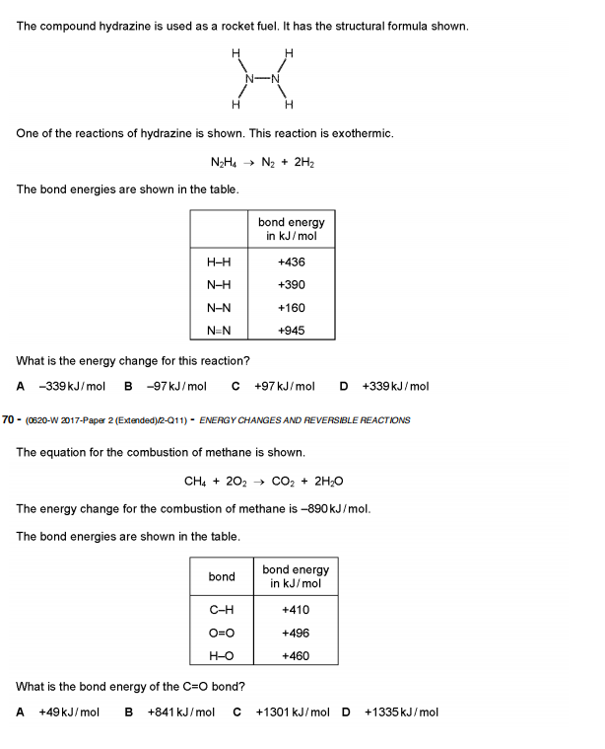
What is the bond energy of the C=O bond? （ ）
A +49 kJ/mol B +841 kJ/mol C +1301 kJ/mol D +1335 kJ/mol

7. Chlorine reacts with ethane to produce chloroethane and hydrogen chloride.
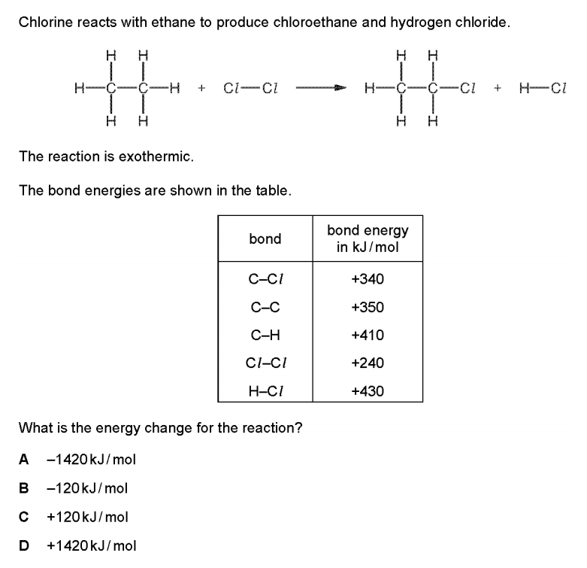
The reaction is exothermic
The bond energies are shown in the table
What is the energy change for the reaction? （ ）
A −1420 kJ/mol B −120 kJ/mol C +120 kJ/mol D +1420 kJ/mol

8. The equation for the complete combustion of methane is shown.
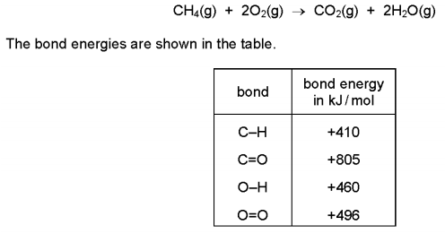
What is the energy change for the reaction? （ ）
A −818 kJ/mol B −359 kJ/mol C −323 kJ/mol D +102 kJ/mol

9. Hydrogen and chlorine react to form hydrogen chloride.
The reaction is exothermic.
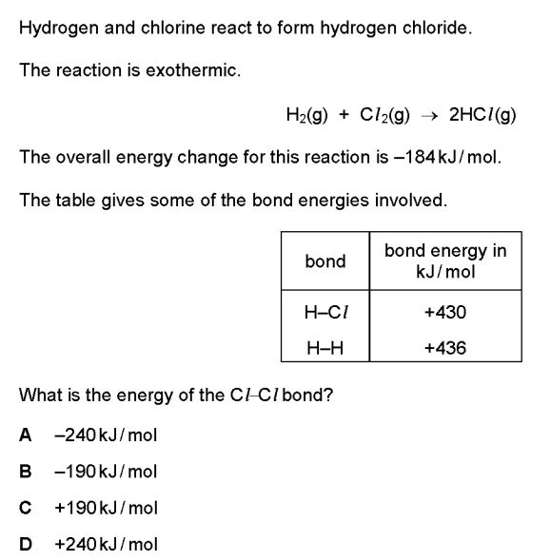
The overall energy change for this reaction is -184kJ/mol
The table gives some of the bond energies involved.
What is the energy of the Cl–Cl bond? （ ）
A −240 kJ/mol B −190 kJ/mol C +190 kJ/mol D +240 kJ/mol
10. The compound hydrazine is used as a rocket fuel. It has the structural formula shown.
One of the reactions of hydrazine is shown. This reaction is exothermic.
The bond energies are shown in the table.
What is the energy change for this reaction? （ ）
A −339 kJ/mol B −97 kJ/mol C +97 kJ/mol D +339 kJ/mol

11. Hydrogen bromide decomposes to form hydrogen and bromine. The equation is shown.
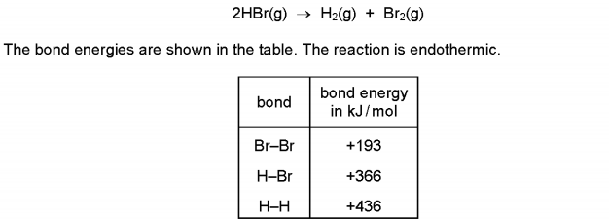
What is the energy change for the reaction? （ ）
A +263 kJ/mol B +103 kJ/mol C −103 kJ/mol D −263 kJ/mol

12. Ethene reacts with hydrogen. The equation is shown.
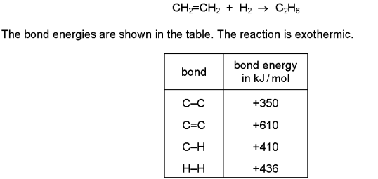
What is the energy change for the reaction? （ ）
A −560 kJ/mol B −124 kJ/mol C +486 kJ/mol D +5496 kJ/mol

Chapter 8 review name: class: due date:5.6
13. The equation for the formation of ammonia is shown.
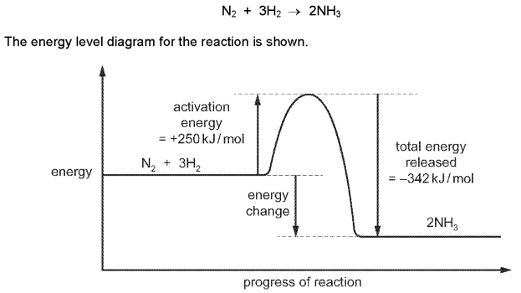
What is the energy change for the reaction? （ ）
A −592 kJ/mol
B −92 kJ/mol
C +92 kJ/mol
D +592 kJ/mol

14. Methane burns in excess oxygen.
The equation is shown.
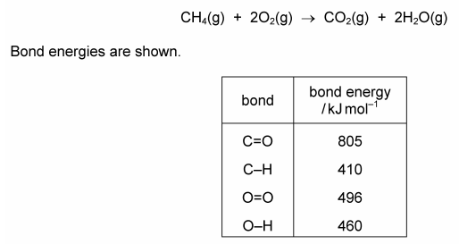
What is the ΔH for this reaction? （ ）
A (4 × 410 + 2 × 496) - (2 × 805 + 4 × 460)
B (2 × 805 + 2 × 460) - (410 + 2 × 496)
C (410 + 2 × 496) - (805 + 2 × 460)
D (410 + 496) - (805 + 460)

16. The reaction between hydrogen and oxygen releases 486 kJ/mol of energy.
2H₂(g） + O₂(g） → 2H₂O(g）
The bond energy of H–H is 436 kJ/mol and that of H–O is 464 kJ/mol. （ ）
What is the bond energy of O=O?
A 430 kJ/mol B 458 kJ/mol C 498 kJ/mol D 984 kJ/mol

18. Bond breaking is an endothermic process. Bond energy is the amount of energy needed to break or form one mole of the bond. Complete the table and explain why the forward reaction is exothermic.
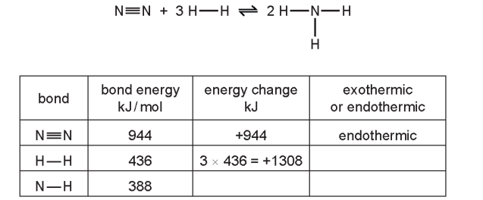
19. Sulfur tetrafluoride , SF₄, can be made by combining gaseous sulfur with fluorine.
S(g） + 2F₂ (g） → SF₄(g）
The reaction is exothermic.
(i) Complete the energy level diagram for this reaction. Include an arrow which clearly shows the energy change during the reaction.
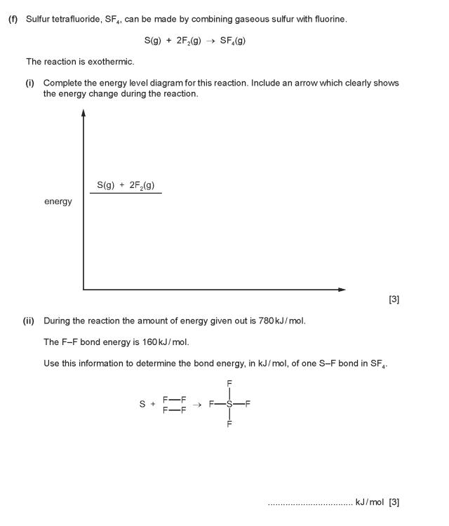
(ii) During the reaction the amount of energy given out is 780 kJ/mol.
The F–F bond energy is 160 kJ/mol.
Use this information to determine the bond energy, in kJ/mol, of one S–F bond in SF₄。

20. Propene also reacts with bromine.
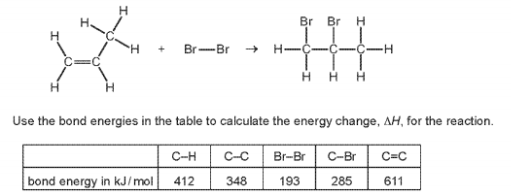

21. The chemical equation for the complete combustion of methanol, C₂H₅OH, is shown.
2CH₃OH + 3O₂ → 2CO₂ + 4H₂O
The equation can be represented as shown.
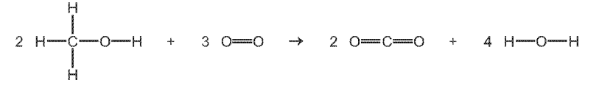
Use the bond energies in the table to determine the energy change, ΔH, for the complete combustion of one mole of methanol.
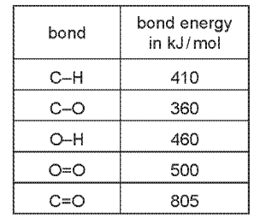
• energy needed to break bonds
............................ kJ
• energy released when bonds are formed

............................ kJ
• energy change, ΔH, for the complete combustion of one mole of methanol
............................ kJ/mol
22. The equation for the complete combustion of ethanol is shown.
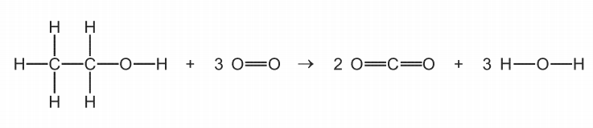
Use the bond energies in the table to calculate the energy change, in kJ/mol, for the complete combustion of ethanol.
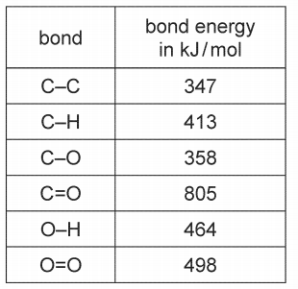
• Energy needed to break bonds.
............................ kJ
• Energy released when bonds are formed.
............................ kJ
• Energy change for the complete combustion of ethanol.
energy change =............................ kJ/mol

23. Hydrogen and chlorine react to form hydrogen chloride gas, as shown in the equation.
H₂ + Cl₂ → 2HCl
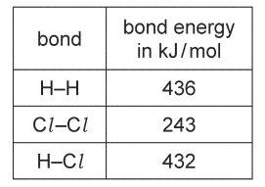
• Calculate the energy needed to break the bonds.
............................ kJ
• Calculate the energy released when bonds are formed.
............................ kJ
• Calculate the energy change for the reaction.
....................... kJ/mol

